

**FPT ACDEMY INTERNATUONAL**

**FPT – APTECH COMPUTER EDUCATTION**



**Centre Name: ACE-HCMC-2-FPT.**

**Address:590 Cach Mang Thang 8, Districs 3, Ho Chi Minh City, Viet Nam.**

**Maru Dry Fruit**

|  |  |  |
| --- | --- | --- |
| **Supervisor.** | Phạm Thị Lánh | |
| **Batch.** | T1.2108.A0 | |
| **Group** | Group5 | |
| **Serial No.** | **Enrolment Number** | **Student Name** |
| 1. | Student1331707 | Tống Nguyễn Thái Ân |
| 2. | Student1328766 | Hồ Đức Hiếu |
| 3. | Student1328507 | Trần Văn Lưu |
| 4. | Student1329016 | Nguyễn Hoàng Anh Dũng |

September 2020

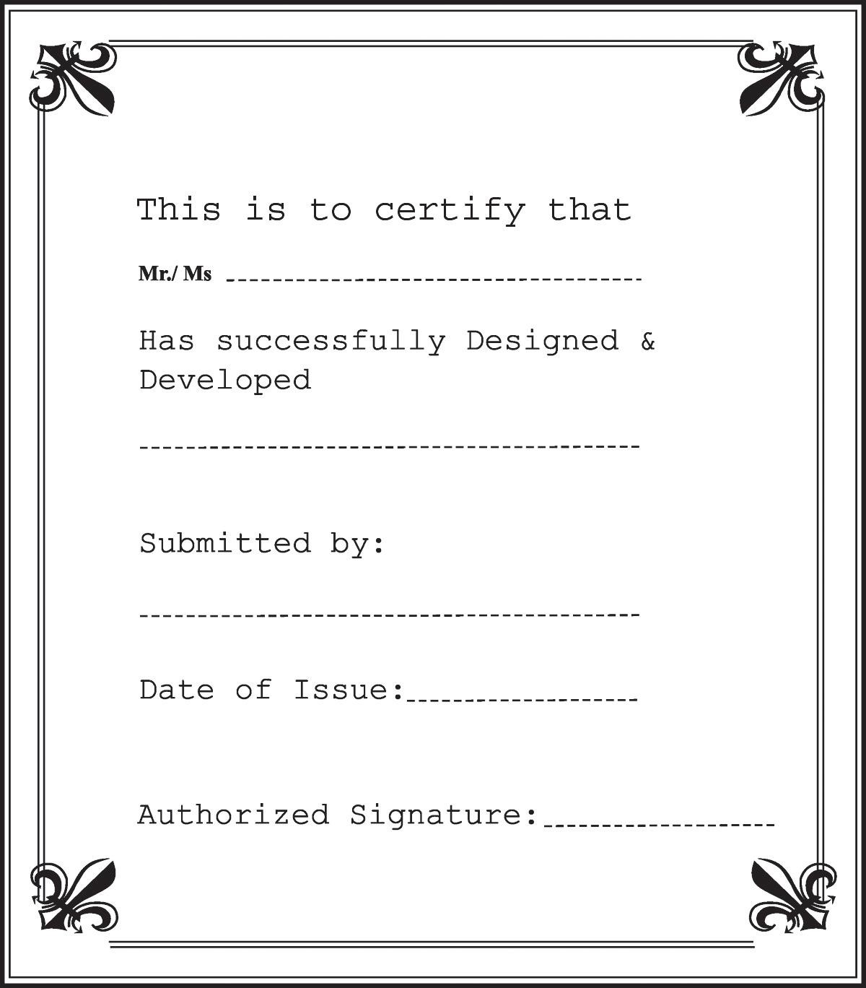

# 1 ACKNOWLEDGEMENT ............................................................................................................3

# 2 SYNOPSIS...................................................................................................................................... 4

# 3 REVIEW 1 ..................................................................................................................................... 5

## 3.1 REQUIREMENT SPECIFICATION .................................................................................. 5

## 3.2 PROBLEM DEFINITION .................................................................................................... 5 6 3.3 CUSTOMERS REQUIREMENT SPECIFICATION (CRS) ............................................ 6 7 3.4 ARCHITECTURE & DESIGN OF THE SYSTEM......................................................... 8

## 3.5 SITEMAP ............................................................................................................................. 9 WEBSITE LAYOUT ........................................................................................................... 10

3.6.1 HOMEPAGE ................................................................................................................. 10 11

3.6.2 LOGIN&REGISTER ........................................................................................................ 12

3.6.3 CART ................................................................................................................. 13

3.6.4 INTRODUCE .............................................................................................................. 14 15

3.6.4 NEWS .............................................................................................................. 16

3.6.4 CONTACT US .............................................................................................................. 17 18

**3.7** **TASK SHEET 1 ................................................................................................................... 19**

# 4 REVIEW 2 ............................................................................................................................ 19 20 5 PROJECT SNAPSHOTS ............................................................................................................20

**5.1** **Home Page ............................................................................................................................ 20**

**5.2 Login & Register ............................................................................................................ 21**

**5.3 Cart ............................................................................................................ 22**

**5.4**  **Product details Page ....................................................................................................... 23**

**5.5** **Introduce: ........................................................................................................................... 24**

**5.6** **News: ...........................................................................................................................24**

**5.7** **Contact Us: ...........................................................................................................................25 26**

**5.7 Footer .................................................................................................................................... 27**

# 6 SOURCE CODE WITH COMMENT .......................................................................................

# 1 ACKNOWLEDGEMENT

The world is a better place thanks to people who want to develop and lead others. What makes it even better are people who share the gift of their time to mentor future leaders. We would like to acknowledge all those who have given us their support and knowledge sharing in the making of this project.

We wish to express our gratitude to the e-Project Team at the Head Office in India, who provided us with guidance and instructions. We would like to thank all the staff members at the Center in India for providing us the opportunity to work on this project and offering us their upmost encouragement through out the process.

We would like to express our special thanks of gratitude to our instructor, Mrs. Pham Thi Lanh at the Aptech Computer Education HCMC for her able guidance and support in completing our project. We would also like to extend our gratitude to the staff at the Aptech HCMC office for providing us with all the facility that was required.

Our acknowledgement to several people whom also helped with: the collections of pictures samples, CSS & JS libraries, the preparation of web development, sample code snippets and tutorials and they are all thanked for their contributions. Special mentions goes to the contributors of Bootstrap 4, the contributors and admins for tutorials sites such as W3C school, Tutorialspoint.com, GeeksforGeeks, and many other learning sites.

And Lastly, to our many friends and family, you should know that your support and encouragement was worth more than we can express on paper. Thank you to our moms and dads for breakfasts, lunch and dinners – we could not have finished the project without being provided with love and daily nourishments.

# 2 SYNOPSIS

Maru dry fruit. a store in the market is quite old and needs a website to advertise products and provide information about products to attract more and more customers.

The BOD’s in their annual general meeting proposed that they should launch a website by the name marudryfruit.com where the user will get all the information about the various dry fruit available in the website of any products on a click of a button.

You are supposed to create a website for them with the below mentioned requirement specifications:

The website is to be developed to provide certain features according to specific requirements by the management.

The website is to be developed for the Windows Platform using HTML5, JavaScript and Geolocation. The site should work well in all leading browsers including Chrome, IE, Firefox etc.

# 3 REVIEW 1

## 3.1 REQUIREMENT SPECIFICATION

***The Website CELLINFO.com is to be created based on the following requirements:***

1. The home page must be designed with beautiful color combination with all the required links defined properly. Also all the section of the webpage must be in used to avoid the blank space.
2. It should include all the variety dry fruits, its rate as per quality.
3. Site should also provide nutrition information about each and every dry fruit.
4. Customer should be able to buy online, quantity as specified by them.
5. The site should display various offers / discounts announced time to time
6. It should also include the festival gift packs.
7. About us, Contact Us, Disclaimer must be included.
8. Contact us page: contact us details with location should be displayed using GeoLocation API (eg. GoogleMaps).
9. Creating an account facility can also be added.
10. Dummy procedure for buying to be added.
11. Sitemap must be added.
12. Navigation of the project must be made smooth.

## 3.2 PROBLEM DEFINITION

After analyzing the Queries coming from different forms The Customer is mainly concerned with Dry Fruit related information, which can be one or all of the following information :

1. Nutritional content in dried fruit?

2. How is dried fruit made?

3. Compare the nutritional value of fresh fruit and dried fruit?

4. Is it good to eat dried fruit? If eaten, what effect does it have?

5. Why is dried fruit so popular?

And much more…

As you can see, there are many questions that cannot be answered online or it will be difficult for the Call operator to explain the full features of the product, which will also consume a lot of time. call by the call operator.

Our website can solve this problem by providing an alternative means for customers to find information at their own pace. The site will give you all of that.

**3.3 CUSTOMERS REQUIREMENT SPECIFICATION (CRS)**

1. Client: Maru Dry Fruit.

2. Objectives:

o Provide a website to display information about products (Dry fruit) categorizing product information according to brands and uses.

o 1. The home page must be designed with beautiful color combination with all the required links defined properly. Also all the section of the webpage must be in used to avoid the blank space.

o If users wish to send us an email or looking for our physical location, users should be able to do so in “Contact Us” page.

o The keywords are “logo”, “menu”, “images”, “pastel color” “Category”, “Menu for various dry fruit”, “Tabular Information”, “Contact Us” , “Send email”, “Geolocation”....

3. Inputs provided by clients:

o Click on clickable links from menu, or search menu.

o Click to clickable links/images in “Products” session to link to product information.

o Click “Contact Us” link to link to “Contact Us” webpage.

o Click “send us an email” to send us email.

4. Hardware Requirement:

o A minimum computer system that will help you access all the tools in the courses is a

Pentium 166 or better o 64 Megabytes of RAM or better

5. Software Requirement:

o Window 7/10 OS or higher o HTML5/CSS/JS supporting browsers o Visual Studio Code.

o Bootstrap 4 o JQuery o Notepad editor

6. Scope of the Work (in brief):

Depending on the decision taken by the management regarding the CELLINFO application, following are the requirements based on which the software needs to be developed:

o Displaying proper Logo, Images, Menu.

o A Web-based GUI to be created for displaying links and clickable images. The menu will stay on the left side navigation bar , it is to be closed with a toggle button. The menu will provide links according to products.

o The users can view and visit the links to their favourite products. When click products, will display nutritional information and quality ratio of each product.

o Website allows customers can buy online, their specified quantity, show different offers/discounts, procedure, Including festive gift packages.

o “Contact Us” to be created to provide link to email to users, Disclaimer must be included in our terms., Our office location will be displayed using Geolocation API (eg. GoogleMaps) embedded in the HTML.

## 3.4 ARCHITECTURE & DESIGN OF THE SYSTEM

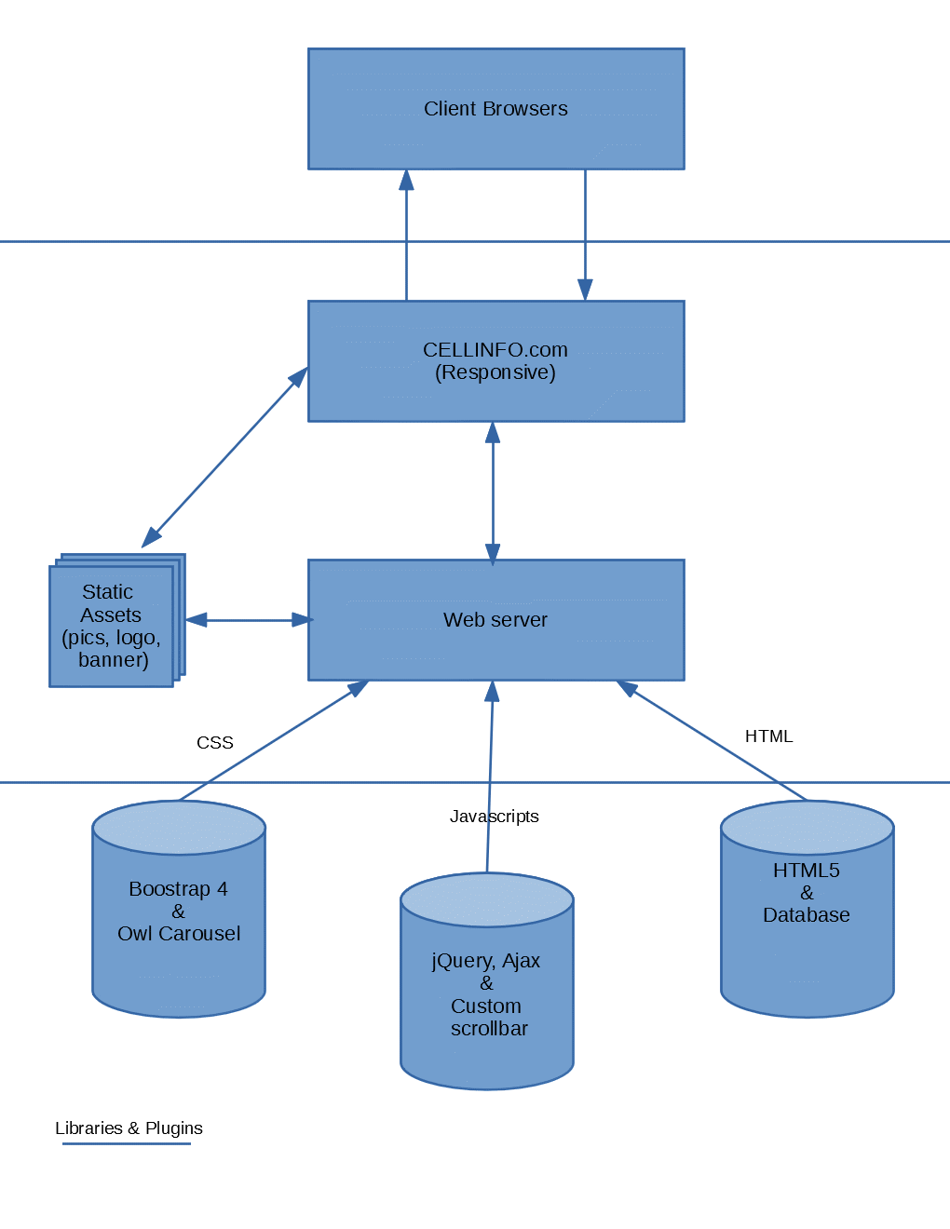

**3.5 SITEMAP**

Home

Domestic mixed dried fruit X

……

Domestic mixed dried fruit X

Domestic dried fruit

Foreign dried fruit

Dried Fruit

News

Contact Us

Introduce

Dried Mixed

Category

Foreign dried fruit X

Foreign dried fruit X

Domestic dried fruit X

Domestic dried fruit X

Foreign mixed dried fruit X

Foreign dried fruit

Domestic dried fruit

Foreign mixed dried fruit X

## 3.6 WEBSITE LAYOUT

## The home page designed with beautiful color combination with all the required links defined properly. Because of the objective is to Full details and SYSTEMICALLY deliver information to the site visitors, the main focus of our webpage will be on the main landing page where all the information will be stored and represented. The site users will have a variety of interactions such as performing search function on a search bar, searching using dropdown menus.

## The websites will also have a few complimentary pages such as About, Contact Us which contain introductory information about our team and our office address.

**3.6.1 HOMEPAGE**

Main content: Our brand of dried fruit is placed on top of the important content , Our homepage is organized in four important sections that are clearly divided and have specific roles. + HOME +introduce +News +Contact us On the menu bar, there is a search bar so that everyone can easily find the dried fruits they want to search for. Next to the search bar, there will be an account registration login section for users to easily buy and sell dried fruits. On the left hand side of the HOME section, there will be a category entry. in this section there is a dry mix section with a downward arrow, when clicking on it the homepage will introduce users to two types of dried fruit, which are domestic dried fruit and foreign dried fruit. The dried fruit section also has a downward sign and introduces the user to the type of dried transplanted fruit

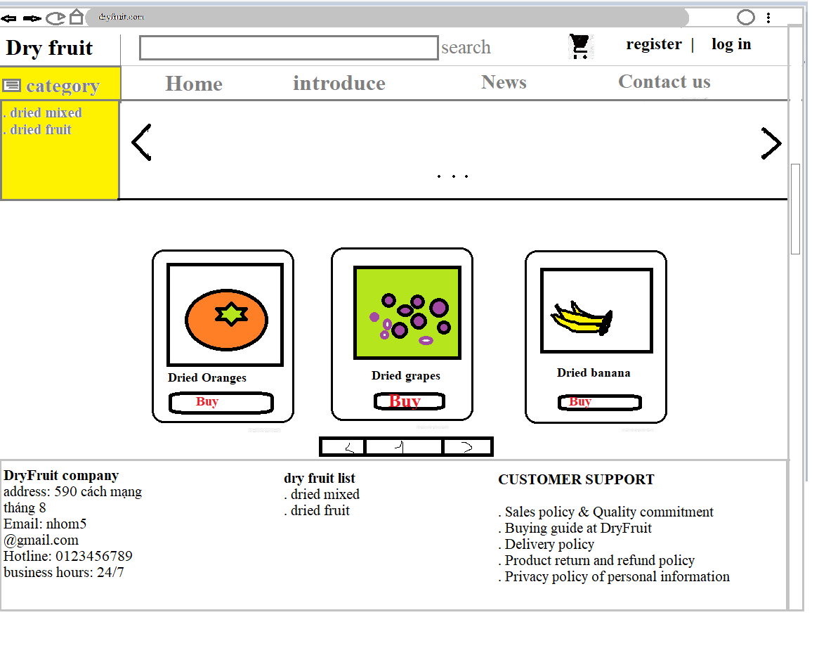

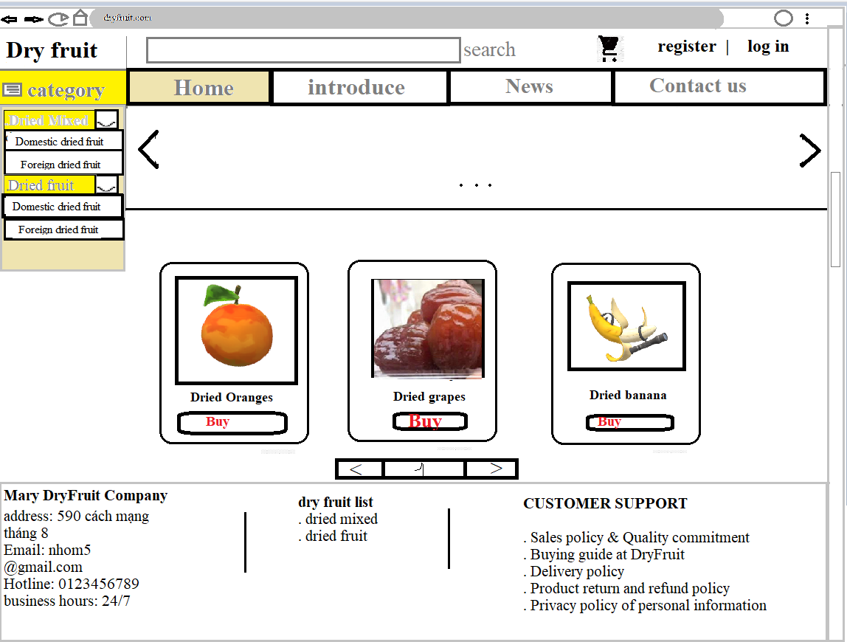

**3.6.2 LOG IN AND REGISTER**

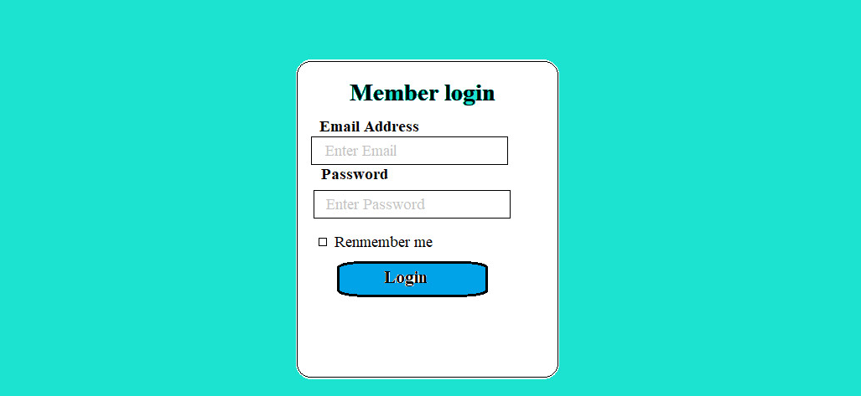

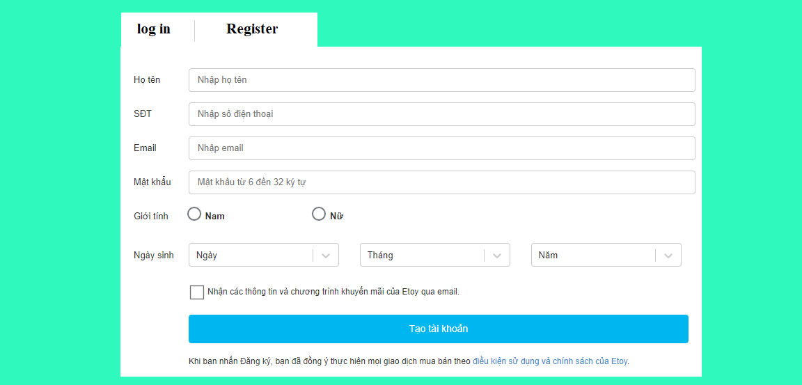

**3.6.3 CART**

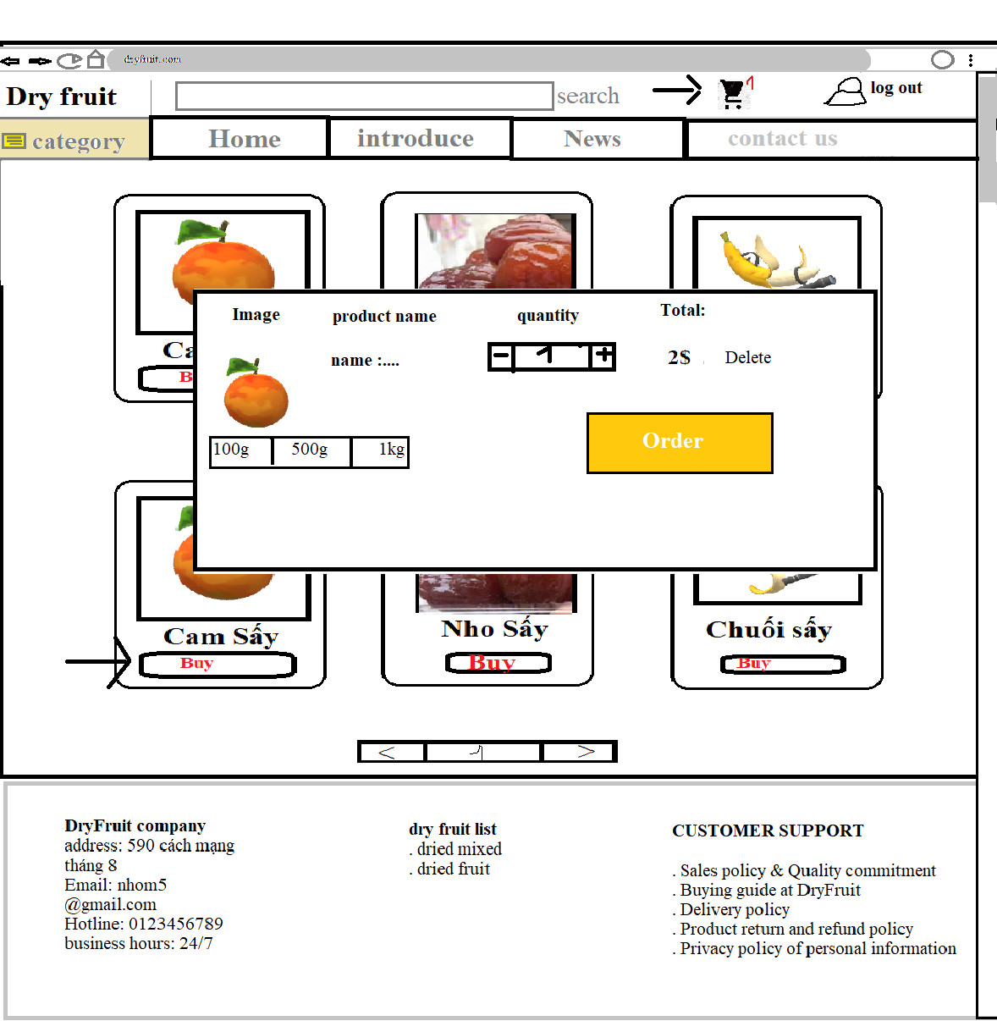

**3.6.5 DETAILS**

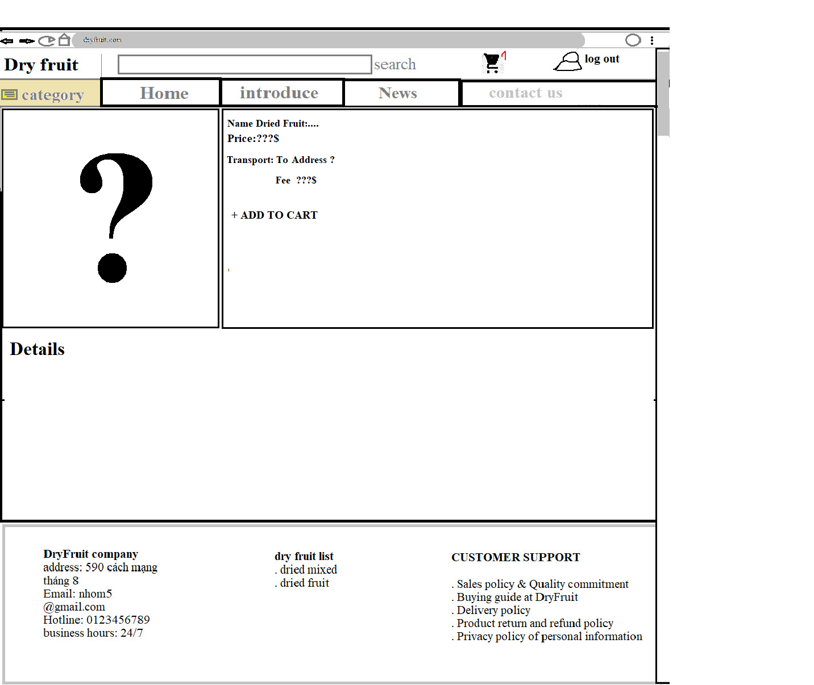

**3.6.2 Introduce**

In addition, we have a customer support section: Commitment to sales and quality, Buying guide at dried fruit, Delivery policy, Product rerun and refund policy, Privacy policy of personal information. 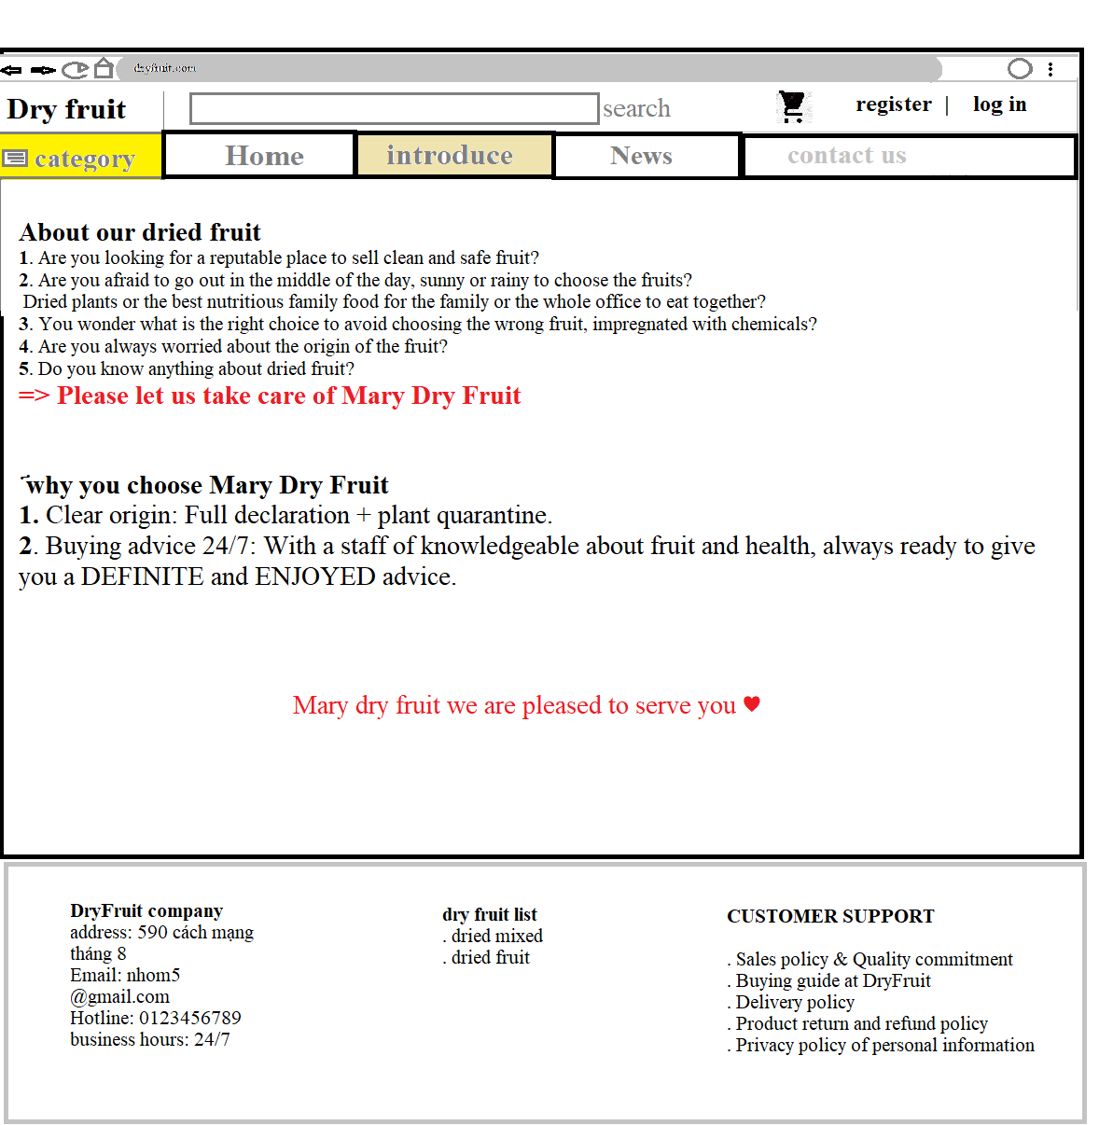

**3.6.3 News**

Provide customers with new information of the website (showing offers, festival packages).

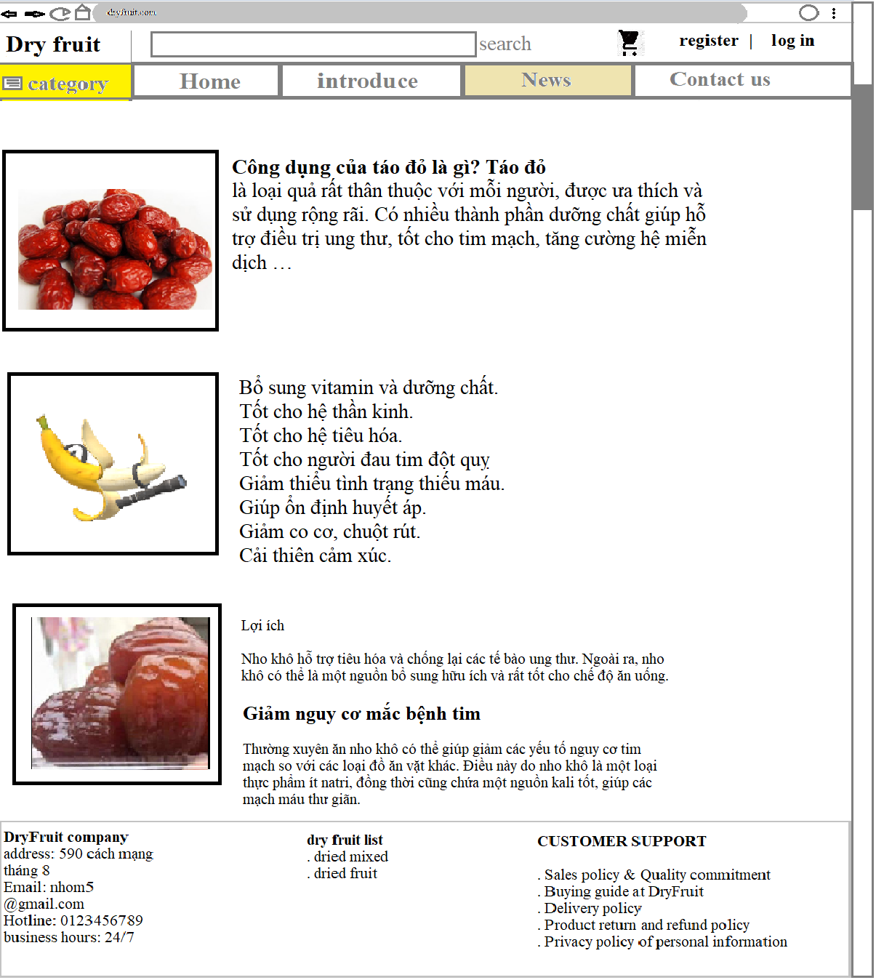

**3.6.4 Contact Us**

The contact us layout will have be beautiful color combination, there will be a main hero banner on top and below are the headings and email link to our office, a feedback form to be populated using Ajax, and our office address along with a geolocation API (eg. GoogleMaps) showing our office location. The topnav menu (Navigation bar) will become “Active” to show which page users are currently in.

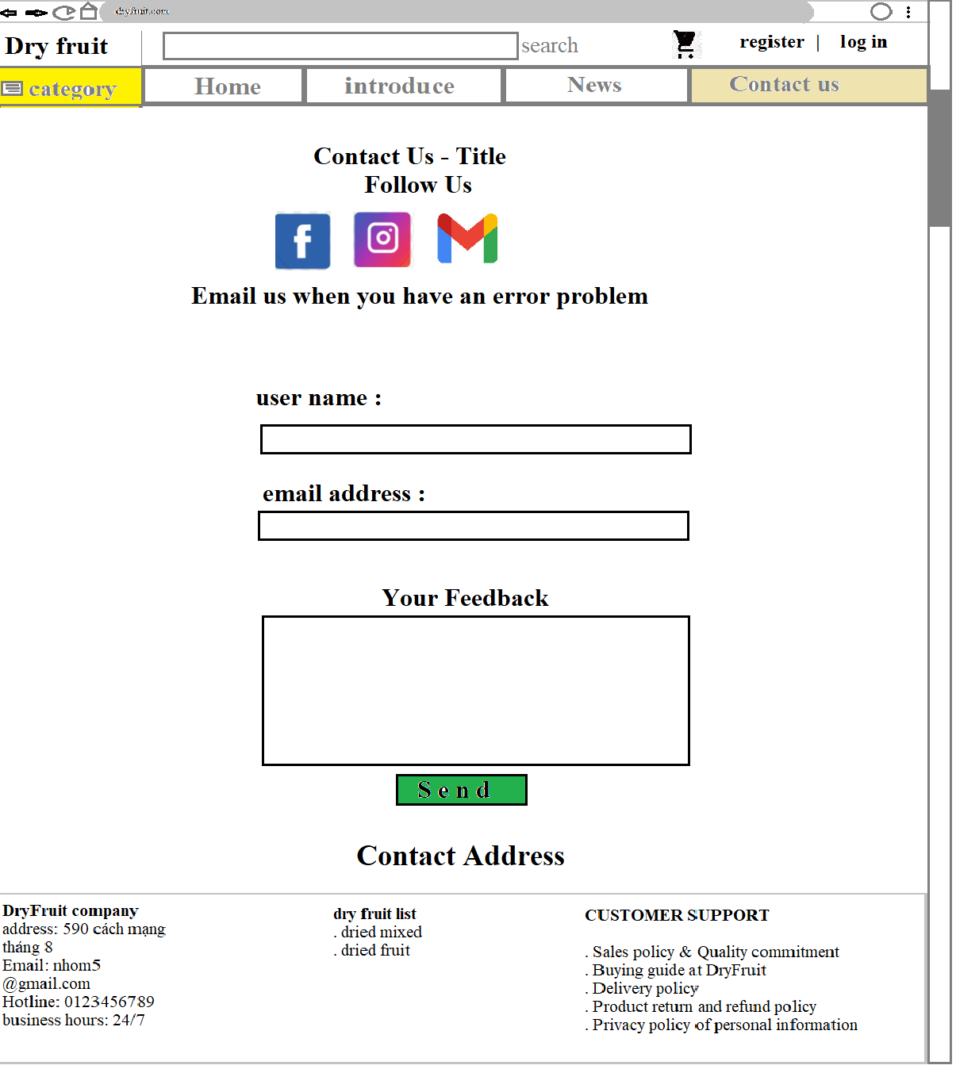

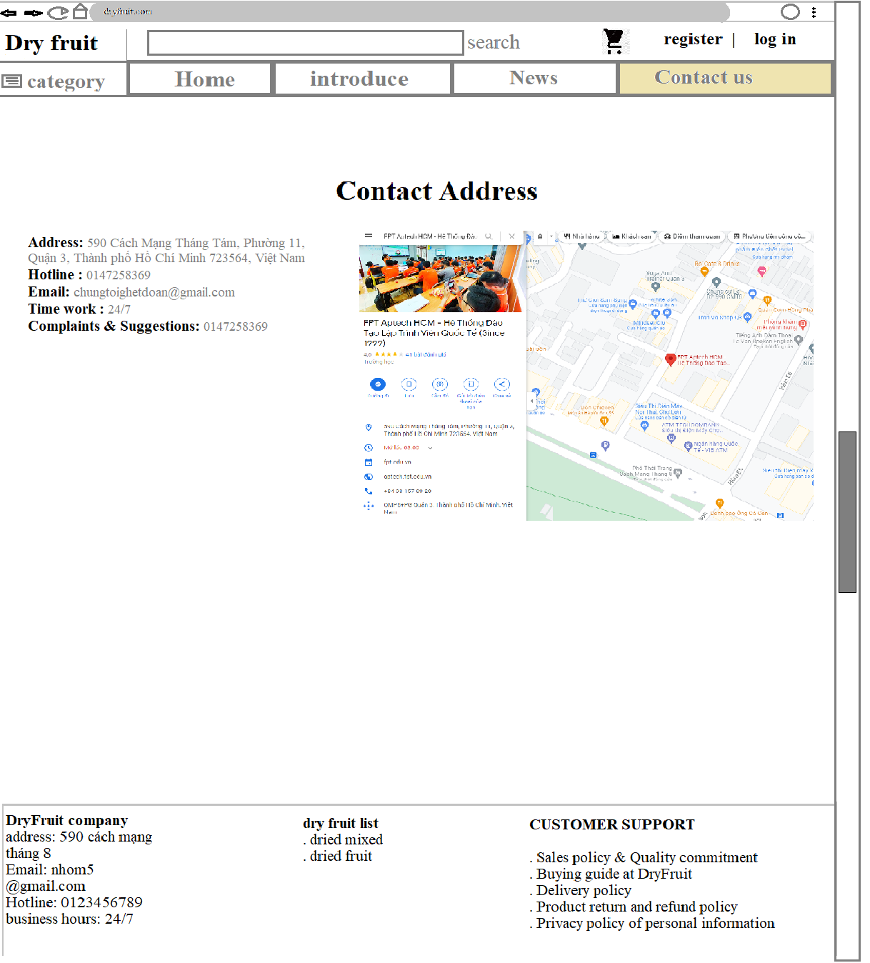

## 3.7 TASK SHEET 1

|  |  |  |  |  |  |  |
| --- | --- | --- | --- | --- | --- | --- |
| **Project Ref No.** | **Project**  **Title – Dry Fruit** | **Activity**  **Plan**  **Prepared by** | **Date of preparation of Activity Plan** | | | |
| **Task** | **Actual Start Date** | **Actual**  **Days** | **Teammate**  **Names** | **Status** |
| Brainstorming ideas for layouts, and Project Objective | | Hiếu, Ân, Lưu, Dũng | 12/11/2021 | 4 day | Hiếu, Ân, Lưu, Dũng | Completed |
| Draw site maps and architecture design | | Ân | 17/11/2021 | 1days | Ân | Completed |
| Wire framing general page layout. | | Hiếu, Ân, Lưu | 17/11/2021 | 2 days | Hiếu, Ân, Lưu | Completed |
| Collect static assets (pictures, mp4, documentation) | | Lưu, Ân, Hiếu, Dũng | 17/11/2021 | 1 days | Lưu, Ân, Hiếu, Dũng | Completed |
| Design & Build Home Page | | Hiếu, Lưu | 17/11/2021 | 2 days | Hiếu, Lưu | Completed |
| Design & Build Contact Us  Page | | Hiếu | 17/11/2021 | 2 days | Hiếu | Completed |
| Design & Build About Us Page | | Hiếu | 17/11/2021 | 2 days | Hiếu | Completed |
| Design & Build Footer Session | | Hiếu | 17/11/2021 | 2 days | Hiếu | Completed |
| Write project report Review 1 | | Ân, Lưu | 17/11/2021 | 2 days | Ân, Lưu | Completed |

|  |  |
| --- | --- |
| Signature of Faculty | Signature of Team Leader |
|  |  |

**4 REVIEW 2**

# 5 PROJECT SNAPSHOTS

## 5.1 Home Page

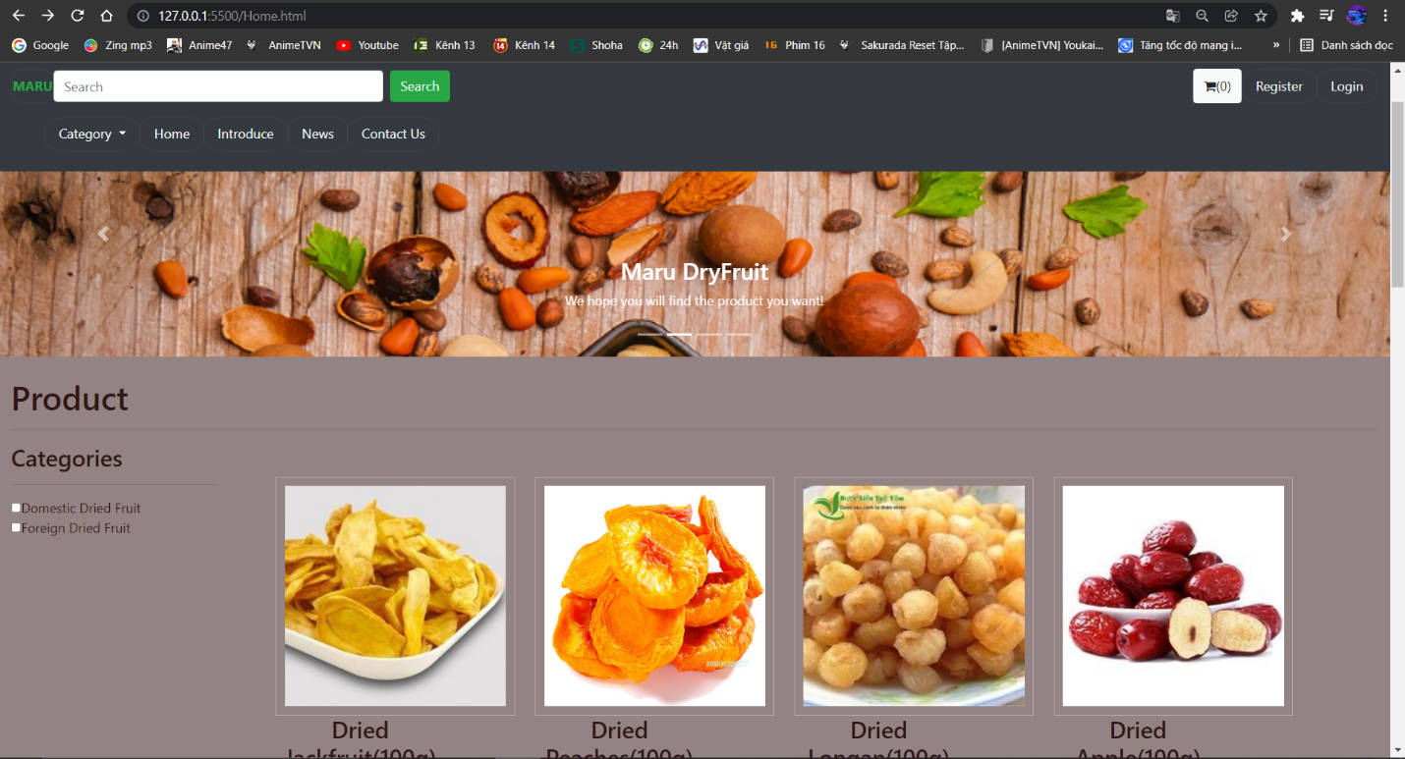

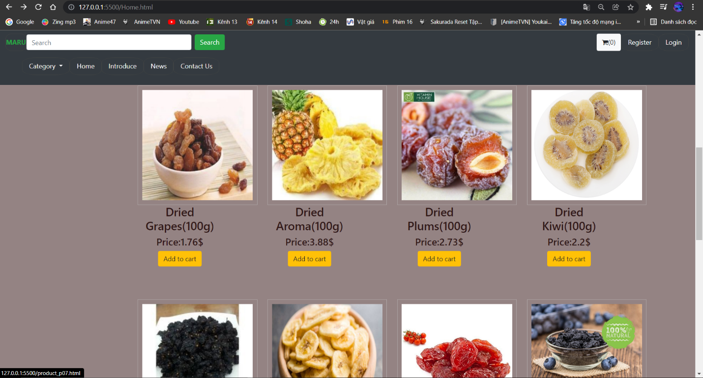

## 5.2 Login & Register

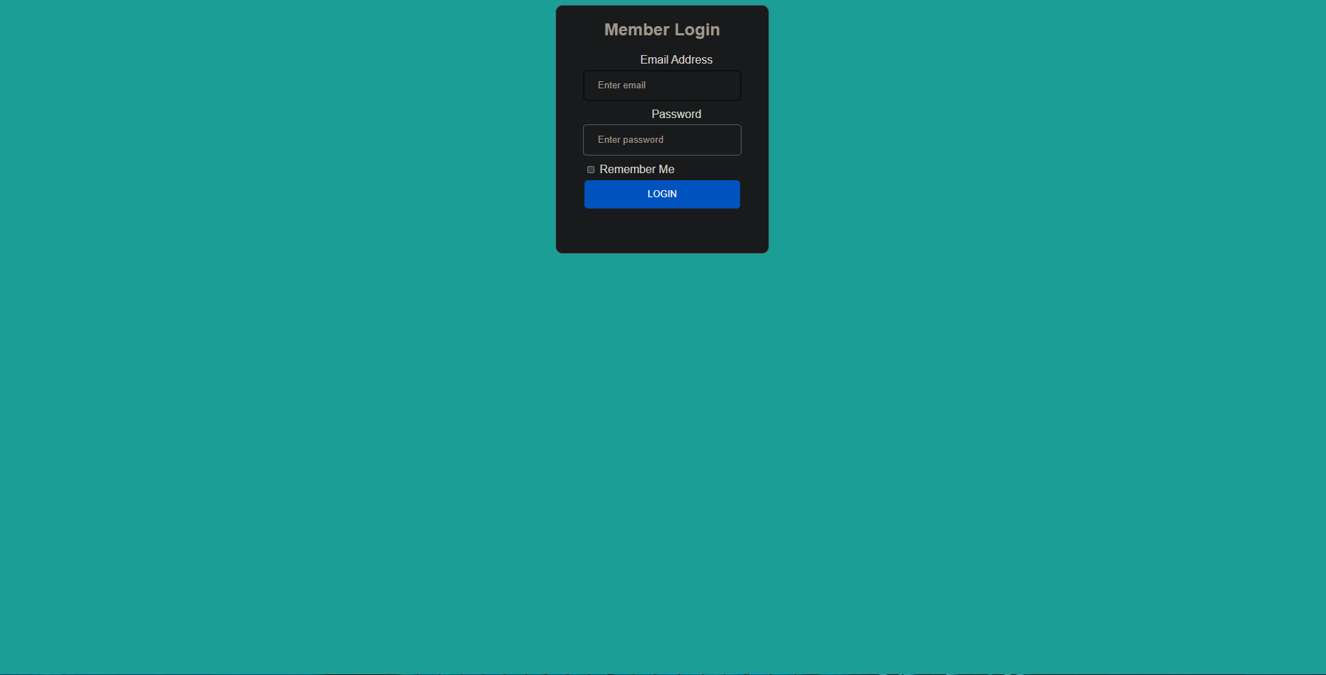

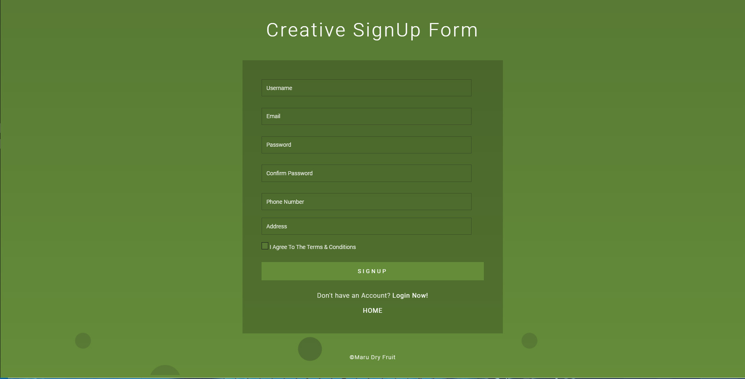

## 5.3 Cart

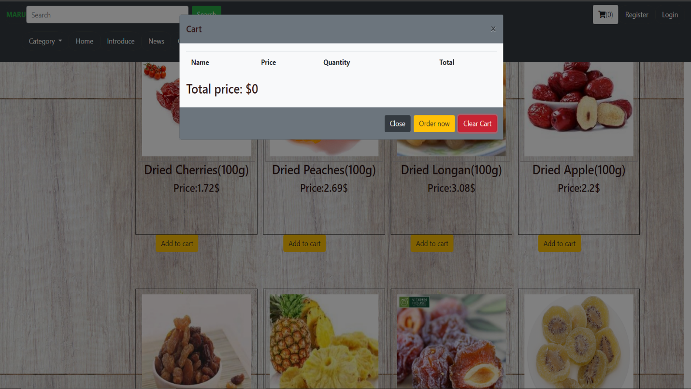

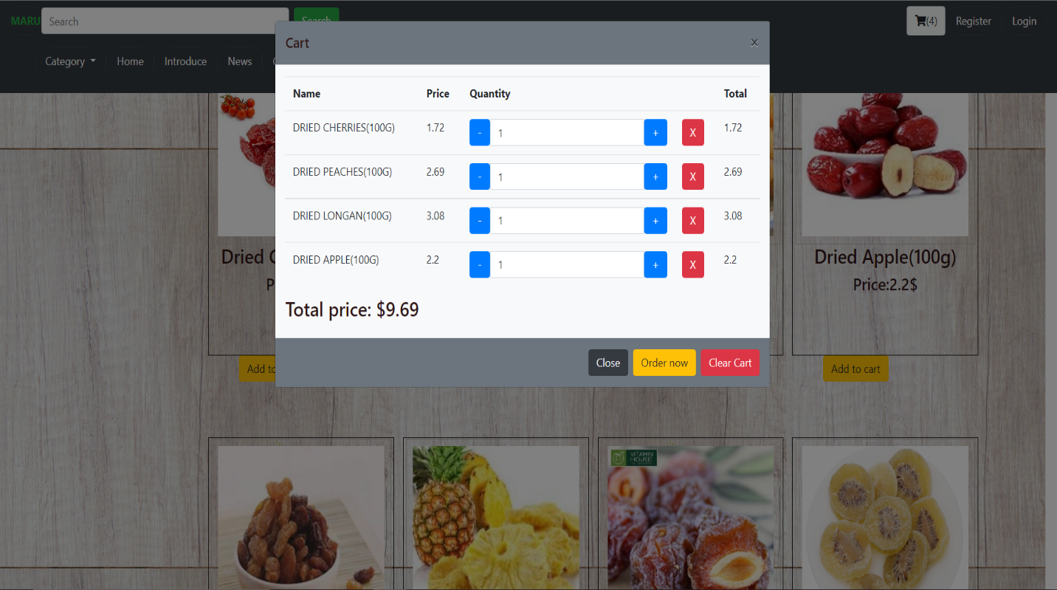

## 5.4 Product details Page

## 

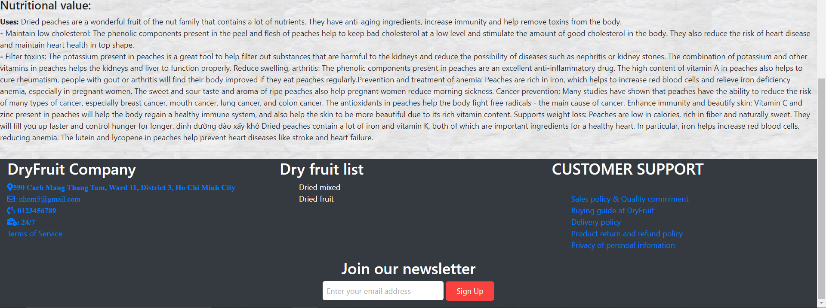

## 5.5 Introduce

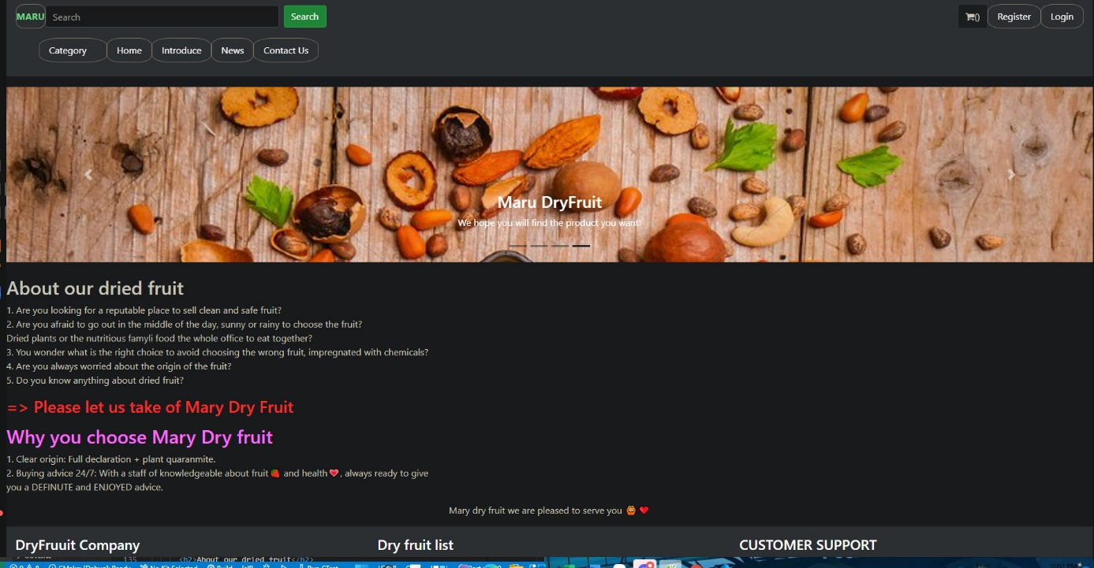

## 5.6 News

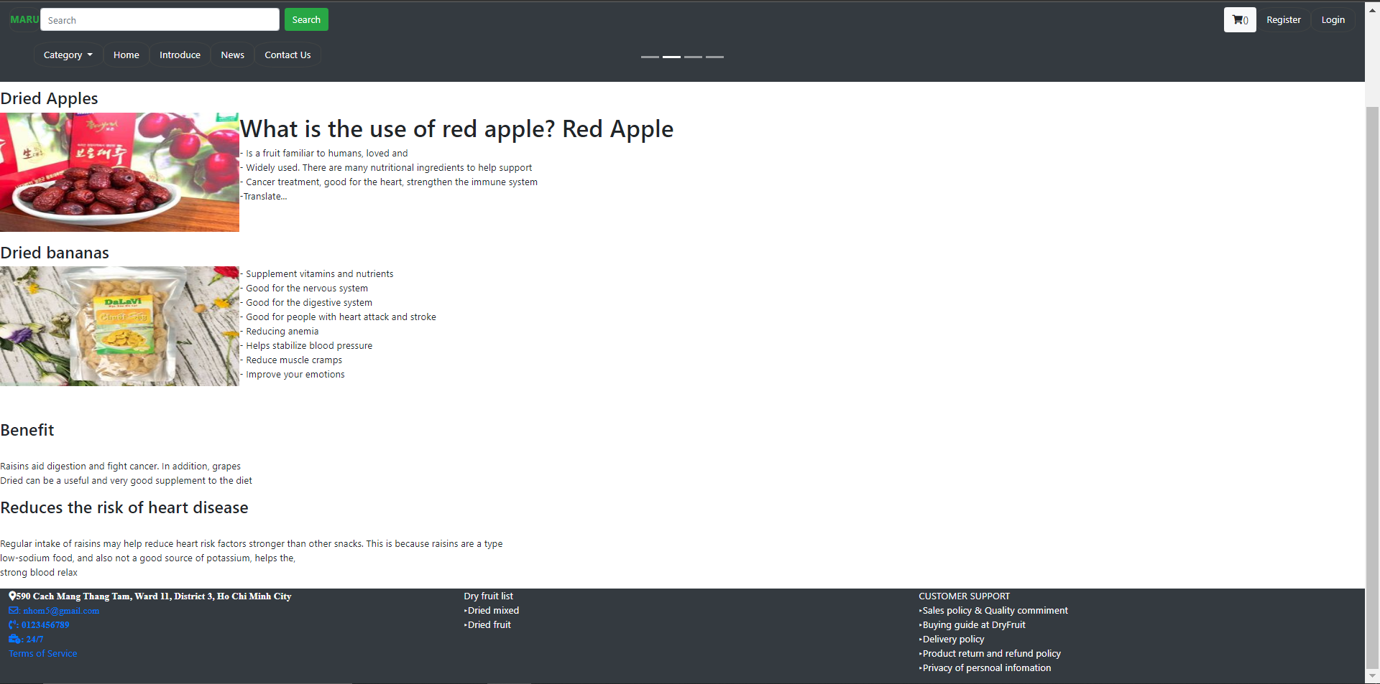

## 5.7 Contact Us

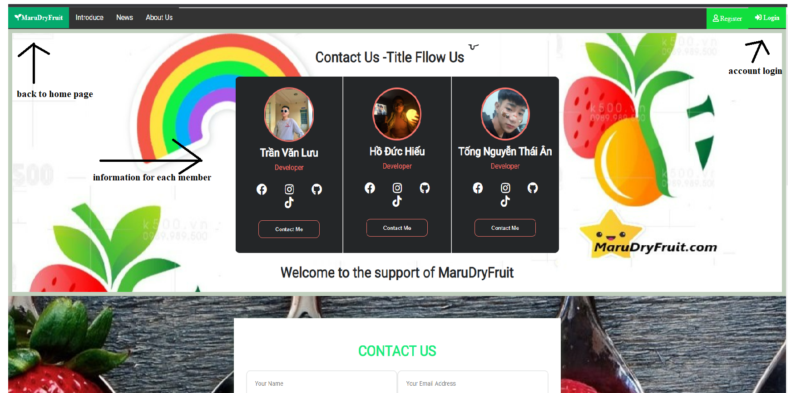

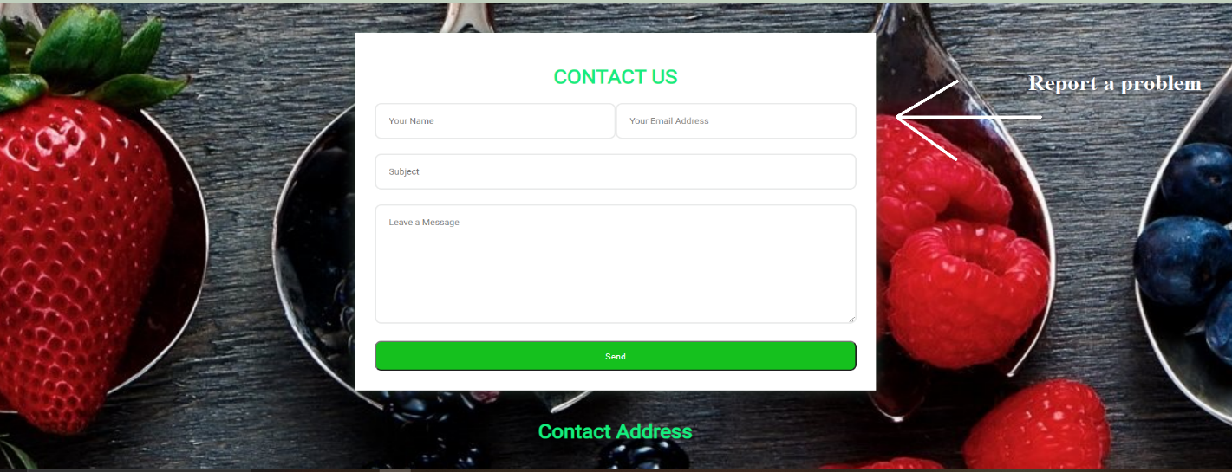

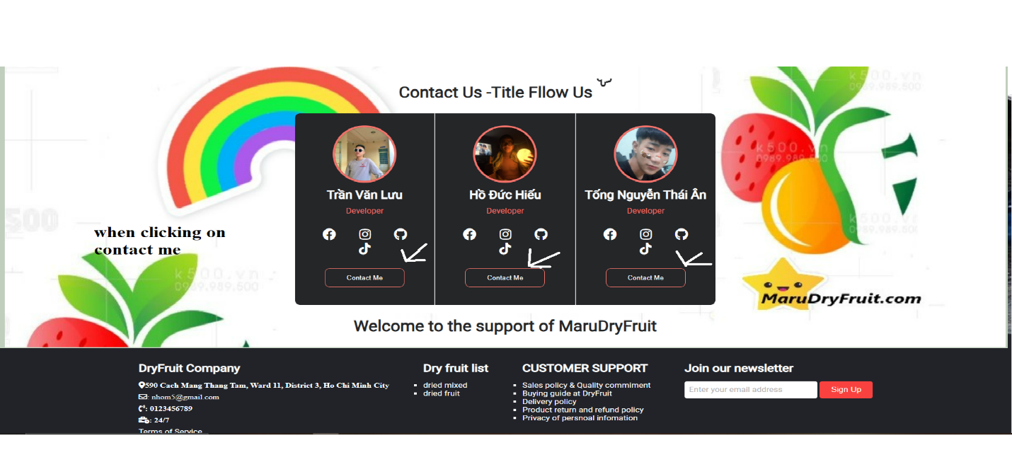

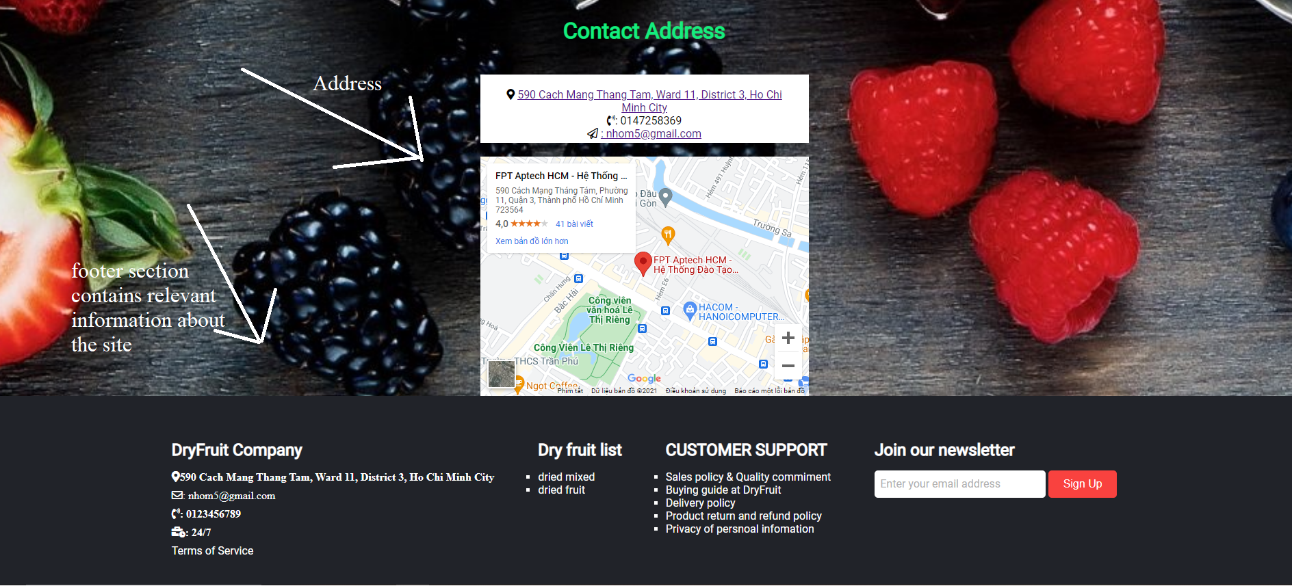

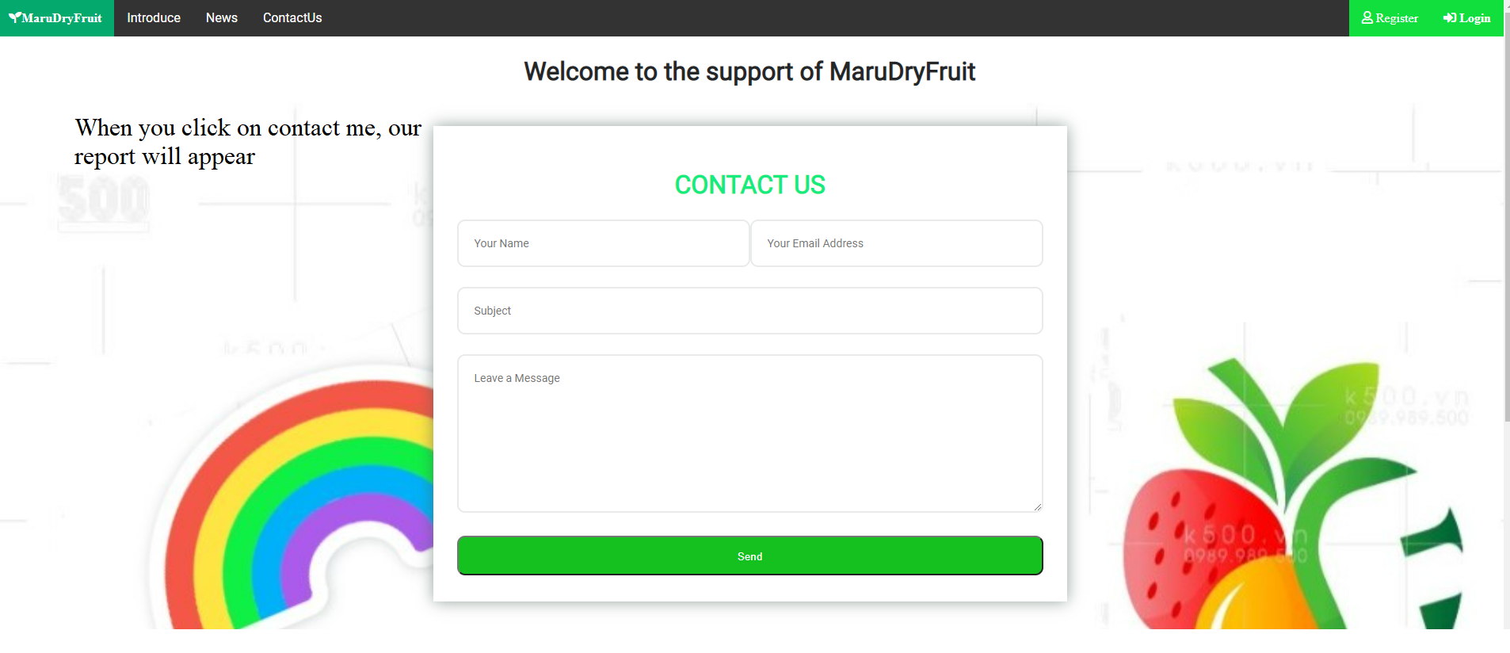

## 5.8 Contact Us

The following snapshot illustrates the creation of MaruDryFruit footer session:

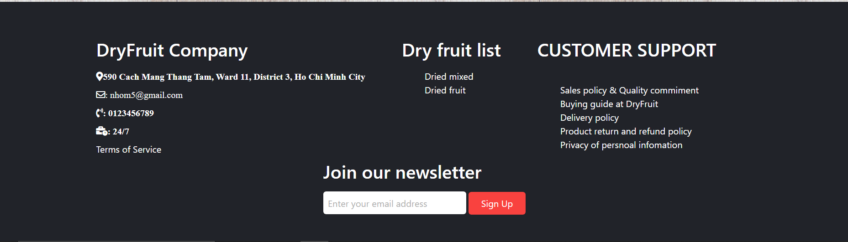

# 6 USER MANUAL

**6.1 System Requirements:**

|  |  |  |
| --- | --- | --- |
| **No.** | **Items** | **Description** |
| 1 | Operating System | Android, iOS, window 7 or higher. |
| 2 | Supporting  Browsers | Chrome, Firefox, Microsoft Edge, IE10+, Opera |

## 6.2 TASK SHEET 2

|  |  |  |  |  |  |  |
| --- | --- | --- | --- | --- | --- | --- |
| **Project Ref No.** | **Project**  **Title – Dry Fruit** | **Activity**  **Plan**  **Prepared by** | **Date of preparation of Activity Plan** | | | |
| **Task** | **Actual Start Date** | **Actual**  **Days** | **Teammate**  **Names** | **Status** |
| Brainstorming ideas for layouts, and Project Objective | | Hiếu, Ân, Lưu | 20/11/2021 | 1 day | Hiếu, Ân, Lưu, Dũng | Completed |
| Design & Build Home Page | | Ân, Hiếu, Lưu | 20/11/2021 to 9/12/2021 | 20 days | Ân | Completed |
| Login & Register Design | | Hiếu, Ân, Lưu | 20/11/2021 to 9/12/2021 | 20 days | Hiếu, Ân, Lưu | Completed |
| Collect static assets (pictures, mp4, documentation) | | Lưu, Ân, Hiếu | 20/11/2021 to 9/12/2021 | 20 days | Hiếu, Lưu, Ân | Completed |
| Design & Build Introduce | | Hiếu, Lưu, Ân | 20/11/2021 to 9/12/2021 | 20 days | Hiếu, Lưu, Ân | Completed |
| Design & Build Contact Us  Page | | Hiếu, Lưu, Ân | 20/11/2021 to 9/12/2021 | 20 days | Hiếu, Lưu, Ân | Completed |
| Design & Build News Page | | Hiếu, Lưu, Ân | 20/11/2021 to 9/12/2021 | 20 days | Hiếu, Lưu, Ân | Completed |
| Design & Build Footer Session | | Hiếu, Lưu, Ân | 20/11/2021 to 9/12/2021 | 20 days | Hiếu, Lưu, Ân | Completed |
| Write project report Review 1 | | Hiếu, Lưu, Ân | 9/12/2021 | 1 days | Hiếu, Lưu, Ân | Completed |

|  |  |
| --- | --- |
| Signature of Faculty | Signature of Team Leader |
|  |  |